San Francisco Bay Area Reading Centers 2016-17
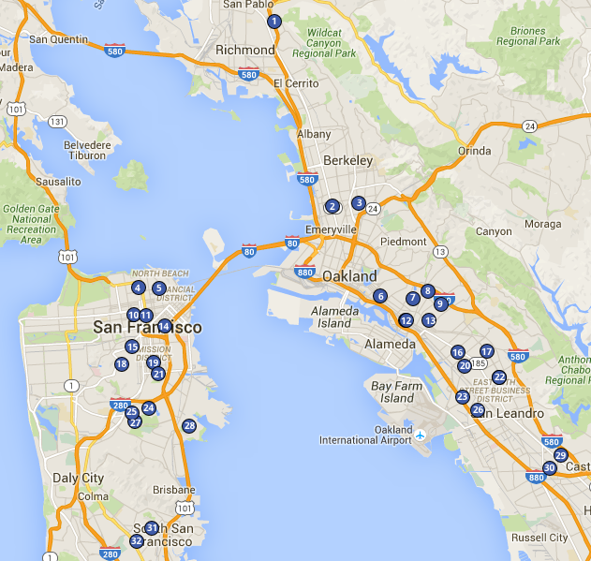

- Riverside Reading Center
- Berkley Maynard Academy Reading Center
- Sankofa Reading Center
- Sherman Reading Center
- Jean Parker Reading Center
- Franklin Reading Center
- Manzanita SEED Reading Center
- Fruitvale Reading Center
- Allendale Reading Center
- Rosa Parks Reading Center
- Tenderloin Community Reading Center
- International Community School/Think College Now Reading Center
- Learning Without Limits Reading Center
- Bessie Carmichael Reading Center
- Sanchez Reading Center
- Futures Reading Center
- Aspire College Academy Reading Center
- Alvarado Reading Center
- Cesar Chavez Reading Center
- EnCompass Reading Center
- Leonard Flynn Reading Center
- Cox Academy/REACH Academy Reading Center
- Brookfield Reading Center
- Hillcrest Reading Center
- Monroe Reading Center
- Madison Park Reading Center
- Cleveland Reading Center
- Bret Harte Reading Center
- Hillside Reading Center
- Hesperian Reading Center
- Spruce Reading Center
- Los Cerritos Reading Center

